**.NetCore Sample Project Documentation**

Topics Covered in the Project

* .NetCore API
* KCS Standard Architecture
* Dapper
* Swagger
* SQL

**Output of the Project**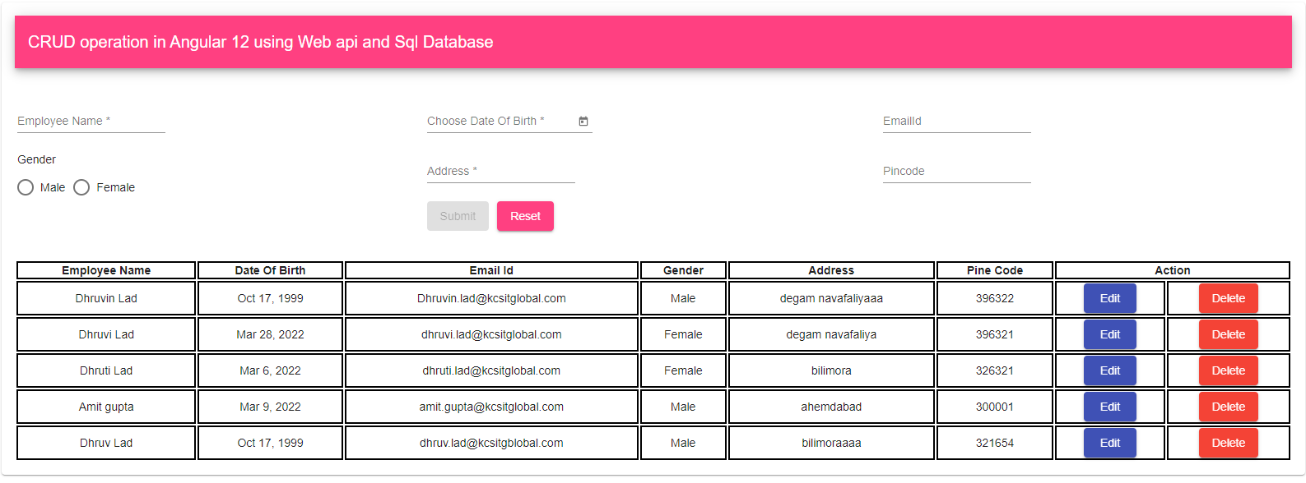

**Step 1. Create a Database table**

Schema of the Database

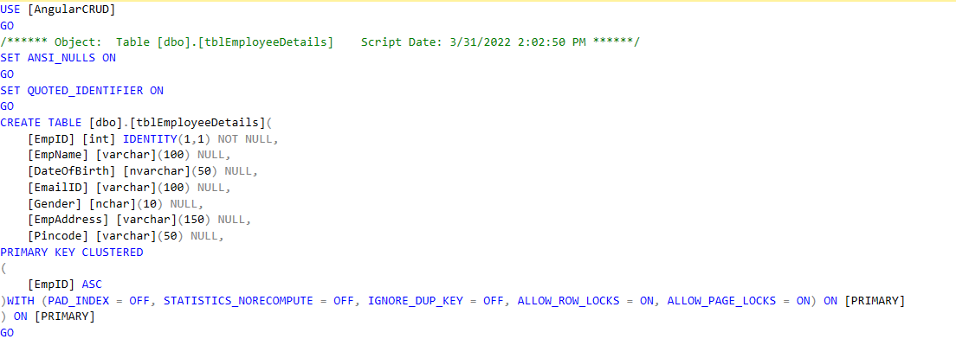

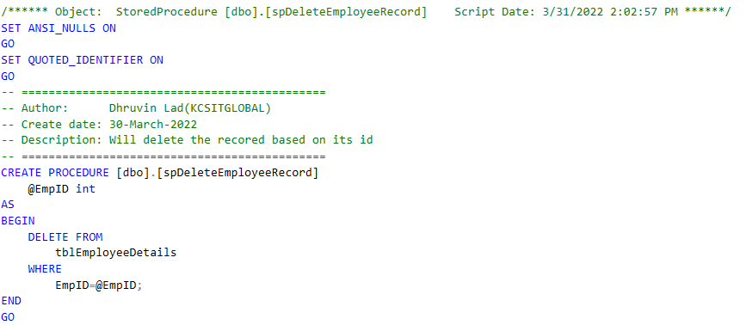

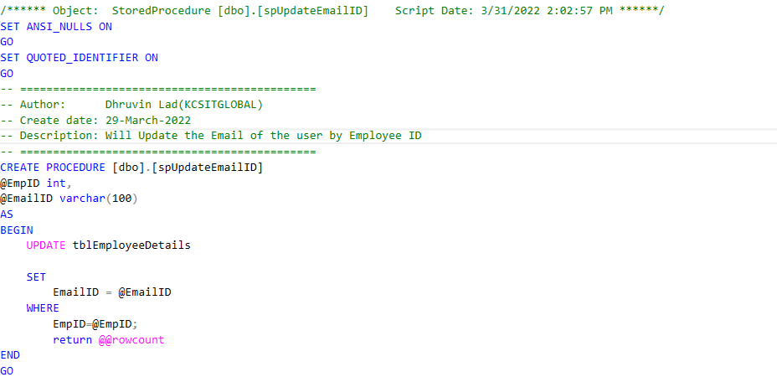

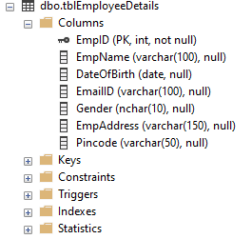

The Schema is Attached Below in the OneDrive At End of Document

## **Step 2. Create a Web API Project**

Folder Structure of the Project

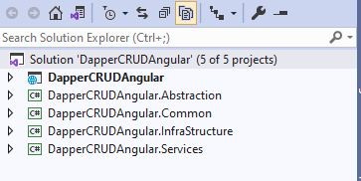

* **DapperCRUDAngular**: WebAPI project or MVC project that holds controllers,views and public resources.

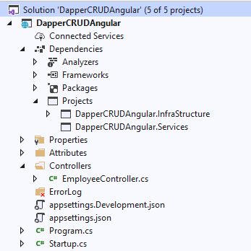

* **DapperCRUDAngular.Abstraction:** All interfaces of the application will be defined here along with models.

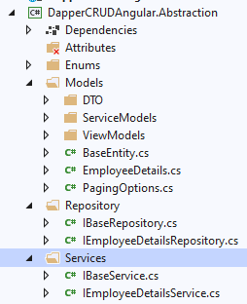

* **DapperCRUDAngular.Common**: This library is used to keep common files and logic at one place and reuse that wherever it is required.

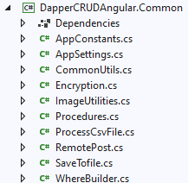

* **DapperCRUDAngular.InfraStructure:** This library is used to handle database operations through Dapper.

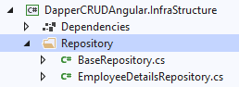

* **DapperCRUDAngular.Services:** This library is used to handle business logic.

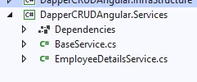

**When using the Web API, Angular blocks the URL and we call this problem CORES (Cross Origin Resource Sharing).**

Make Sure to Enable Core If the Project is Alread Prepared and just want to consume Api in the angular project in STARTUP.CS file

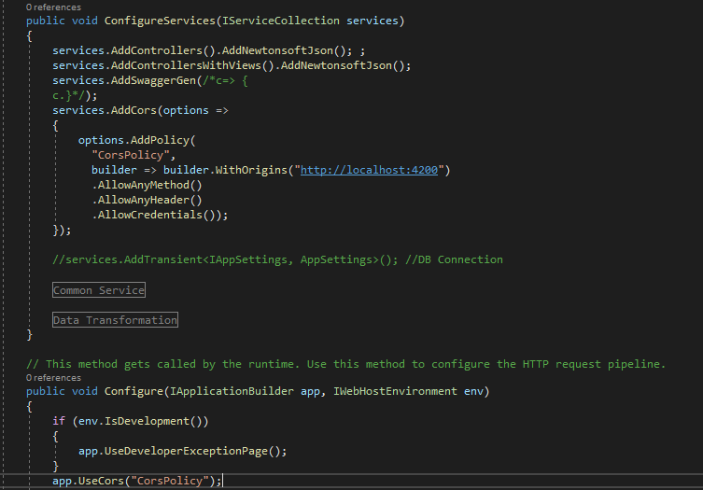

Also use swagger to test the Api

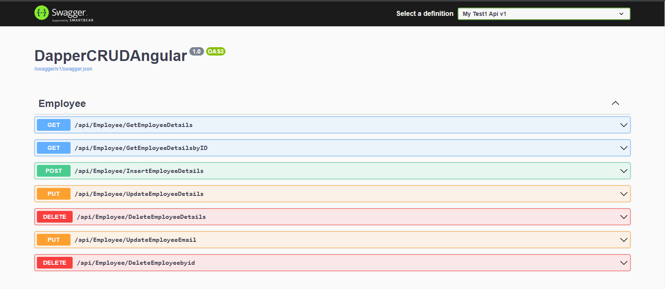

The Code is Attached Below in the OneDrive At End of Document

## **Step 3. Build UI Application in Angular**

We need to create a web application in angular that will consume the web Api, we created in asp.net.

First, we have to make sure that we have install Angular Cli.

we need to open Command Prompt and Type (npm install -g @angular/cli).

now, open the visual studio code for angular project.

open visual studio code Terminal>>New Terminal write command to create angular project ***ng new*** ***AngulerCRUD***.

While New Creating the Project they will ask to include the routing press y

And alter will ask for which type of CSS file u want and select CSS file

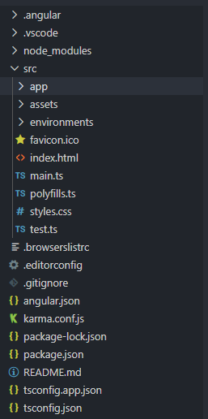

create a new Component Called Employee.

command to create component.

ng g c employee

It Will be created in src->app->employee

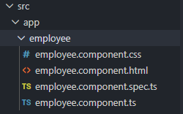

## **Step 4. Create a Service in angular app**

command to create a service for Employee component

ng g s employee

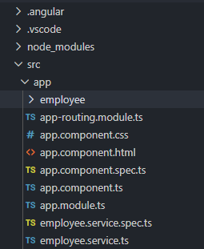

create a class for model class.

command to create a class

ng g class employee

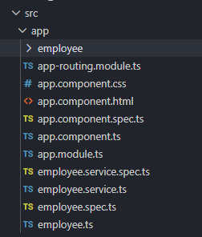

Add the Database Model field in the employee.ts file

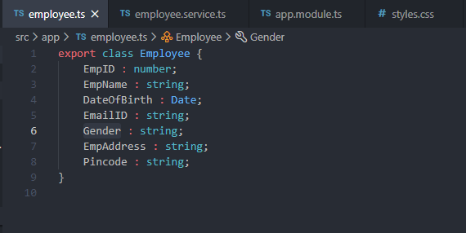

Open employee.service.ts and start importing the required category and libraries and making calls on Web API routes.

Please refer the link below and open the **employee.service.****ts for Code Reference**

## **Step 5. Install and Configure Angular Material Theme**

Command to install material theme

*npm install –save @angular/material @angular/cdk @angular/animations*

To Check installed successfully, we can check in package.json file.

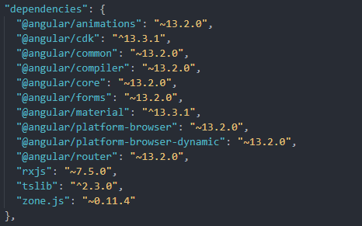

open the app.module.ts section and import the necessary Module

We have to import library in styles.css file. For implementing the theme in project

@import '[@angular/material/prebuilt-themes/indigo-pink.css](http://@angular/material/prebuilt-themes/indigo-pink.css)';

Different options for theme are listed below

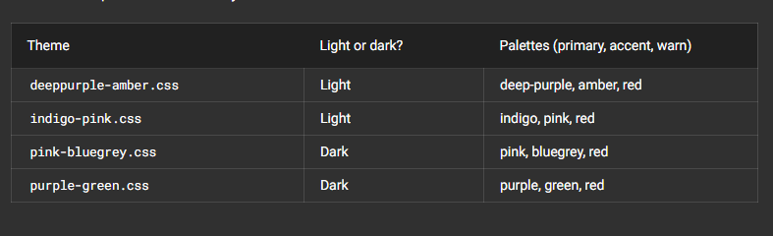

You can also refer to this link for more information: -

https://material.angular.io/guide/theming

## **Step 6. Design DOM or HTML**

Open employee.component.html and make the form accordingly

Source code is available in the link below

## **Step 7 Open app.component.html**

For importing the code of employee.component.html file use the below code in app.component.html file

<p>

<app-employee></app-employee>

</p>

## **Step 10 Open** **employee.component.ts file**

All the logic will be available in this file to handle the request made from the form

Source code is available in the link below

## **Step 11. Finally run the Angular App**

command to run project

ng serve ***AngulerCRUD***

***Make Sure that the Api project is running in the background for consuming the requested call***

***If Your Api is already hosted no need to call the Run the project***

.NetCore Sample Project Link: -

[.NetCoreSample3](https://github.com/kcsplcompusoft/Sample.NetCore3)

Reference Link: -

CRUD Operation video There are many bugs in this video but you can have a reference to see the process

[how to perform Crud Operation in Angular 9 with Asp.net Webapi using Visual studio 2019](https://www.youtube.com/watch?v=H-vGzQHsiec)

